MARKING POLICY

Date reviewed | September 2025
Reviewed by | Rashta Bibi
Approved by | AA/FP
Planned Review date | September 2026

This policy gives guidance to staff on the purpose, types and frequency of marking.

Aims
All marking should have a clear purpose for either the child or the teacher depending on the learning objective.

Purpose of marking
The main purpose of marking should be:
- to help pupils make progress
- to identify strengths and areas for development (targets)
- to show pupils how to improve
- to value/acknowledge pupils’ work
- to inform the teacher of a child’s progress and needs for future planning.
- to provide feedback about current work.
- to allow for self-assessment where the child can recognise their difficulties and mistakes and encourage them to accept help/guidance from others.

Marking Guidelines & Frequency
- Individual pupil targets based on prior attainment and available benchmarking data, e.g. SATs tests/ baseline assessments must be shown clearly on the front of exercise books
- In general, pupils’ work (both classwork and homework) must be marked as follows:
  - where there is only one lesson a week, books must be marked twice every half term
  - where there are two lessons a week, books must be marked at least once every three weeks
  - where there are three or more lessons per week, books must be marked every three weeks
  - marking must be signed and dated
  - effort grading sticker must be given

- Presentation, spelling, punctuation and grammar should be corrected when appropriate. It is important to mark for literacy, but this does not necessarily mean highlighting every mistake, as this can be demotivating
- Where pupils have marked their own work or that of another pupil, the teacher must check that this is accurate and acknowledge the relevant pages, making amendments as necessary.
- Peer assessment involves more than merely checking a pupil’s work from a given answer sheet, and requires the marker to assess the work independently according to known criteria.
- Feedback (including peer assessment) should include suggestions for the next steps for improvement
- Time should be given for pupils to respond to feedback and ask questions for clarification. This could involve whole class teaching where there are common misconceptions.
- Feedback should not give the complete correction but instead give scaffolding so pupils can build the correct response for themselves.
- Feedback should be specific and constructive - it is essential that pupils feel confident that improvement is possible.
- Unless the work is of an exceptionally poor standard, feedback should always begin with highlighting the positive and be followed with constructive next steps.
- Merits should be awarded as a way of motivation for pupils good work and/ or improvement
Marking Codes
- All marking will be in accordance to the Marking Code Poster which will be displayed in each classroom.

Literacy Standard
- All teachers to understand that they are teachers of literacy, no matter what subject they teach.
- Teachers are required to look out for the quality of literacy across all subjects and are expected to amend any literacy mistakes a pupil may make, but this does not necessarily mean highlighting every single mistake, as this can be demotivating
- This will include sentence structure, spelling, grammar, punctuation and handwriting.

Mathematics and English
- The teacher will mark students’ books according to the Marking Guidelines & Frequency above
- Students will be assessed apart from this weekly by way of a short test on the objectives covered that week. This will enable timely intervention should it be required.
- Teachers will keep an overview of peer or group marking. This again will enable timely intervention if required.

Monitoring of Marking
- It is the responsibility of each individual teacher to ensure that marking is completed promptly, as laid down in the whole school policy.
- The SLT are responsible for regularly checking that pupils’ work is marked in line with the school policy.

Explanation of effort grades
- Excellent - Work (including presentation) has been completed to the very best of the pupil’s ability
- A good level of effort is evident in the work produced
- Satisfactory effort but clearly not the pupil’s best work
- Poor – work is incomplete, rushed or indicates little care has been taken.

Marking Code
Marking will be carried out in accordance with the marking policy. The following are explanations of the marking code to be used.

 | Correct – good point – well written
 | Incorrect – wrong point
sp | Spelling mistake
? | This does not make sense
^ | You need to add a word
“ | You need to start a new paragraph
T | Target (in order for you to improve you need to…)
 | Great thinking
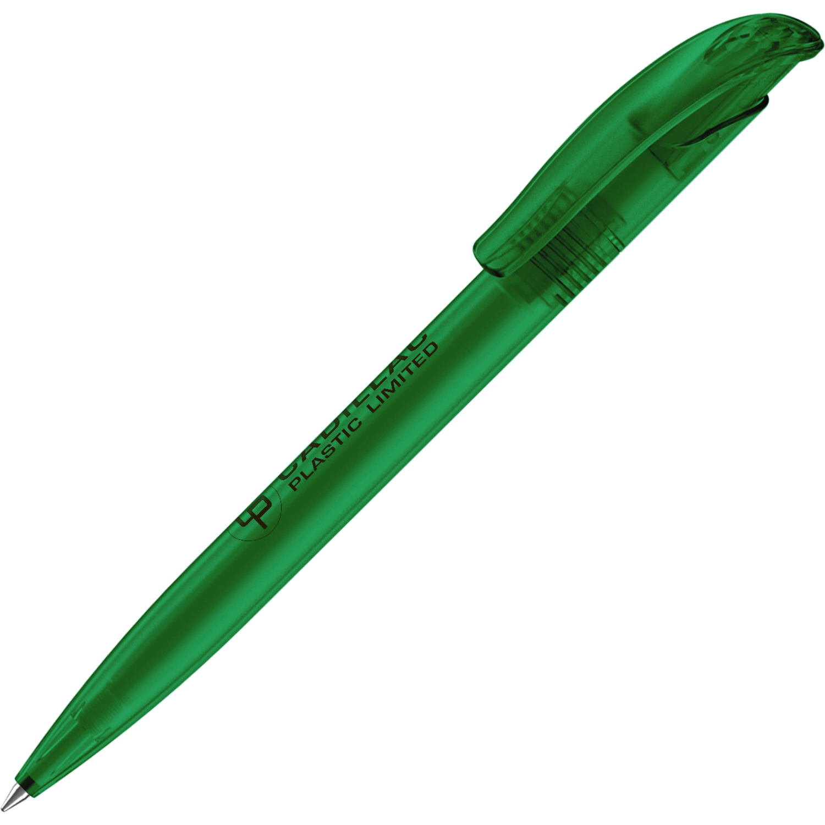 | Peer marking in green pen

